Unattached Disks:

Query to find the list :



List of unattached lists :



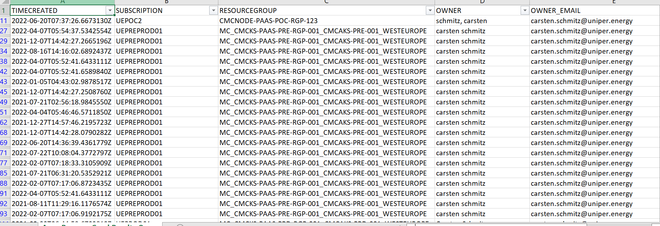



Disk may be unattached due to POD reboot or deletion .

When we describe PVC we can find the namespace and the POD name which it uses as below .

rt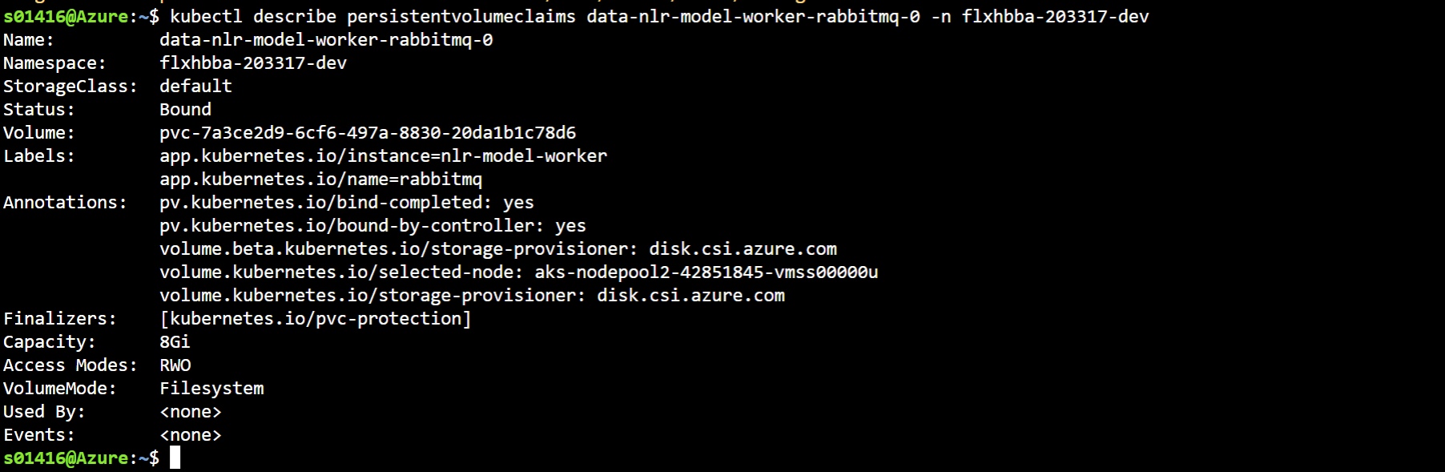

Need to send the list of PVC with namespace owner to determine whether it is needed or deleted .